**Command and Control**

*Response Cluster*

National Disaster Risk Reduction and Management Council

SOFTDEV & QUALITY @ Asia Pacific College S.Y. 2016 – 2017

**Project Professor:**

* + Mr. Edmundo Casiño SOFTDEV and QUALITY Professor

**Project Team:**

* + Carl Dominique Bueno Project Manager/Developer
  + Maica Belchez Project Analyst/Documenter
  + Abigail Malapo Assistant Documenter/Quality Tester
  + Jorome Mortera Assistant Documenter/Quality Tester

**Client Information:**

Company/Organization Name: National Disaster Risk Reduction and  
 Management Council (NDRRMC)

Department of Social Welfare and  
 Development (DSWD)

Project Name: Command and Control

Response Cluster

Primary Contact Person: N/A

Position: N/A

**About Command and Control Response Cluster:**

Lead Agency: Philippine National Police (PNP)

Member Agency(s): Armed Forces of the Philippines (AFP)

Department of Foreign Affairs (DFA)

Office of the Civil Defense (OCD)

Department of the Interior and Local Government (DILG)

Department of Health (DOH)

Metropolitan Manila Development Authority (MMDA)

Regional Emergency Assistance Communications Team (REACT)

National Bureau of Investigation (NBI)

Philippine Red Cross (PRC)

Bureau of Fire Protection (BFP)

Department of Public Works and Highways (DPWH)

Philippine Coast Guard (PCG)

International Federation of Red Cross (IFRC)

International Committee of the Red Cross (ICRC)

United Nations Disaster Assessment and Coordination

1. **Introduction**

**Mission Statement**

Maintaining peace and order on disaster circumstances. Therefore, providing an effective and integrated response to disaster situations through execution of standard procedures and protocols and a centralized disaster management system.

**Problem Statement**

Disaster is just around the corner and it may possibly happen anytime, local government units are expected to be at the frontline of emergency measures in the aftermath of disaster. Hence, government lacks on integration of disaster assessments to be drawn from local to national level and standard disaster protocols to execute an operative response action. Identifying the alert systems to be declared within the affected area for obligatory actions from local to national level of the government.

Another problem exist to present situation are the methods and criteria of determining the type of disaster and its risks, the level of damage, identifying the number of victims and evaluating the condition of the area. Moreover, disaster response includes suitable relief services and assistance to be provided by different sectors and volunteers.

**Project Context**

***Conceptual Framework for Command and Control***

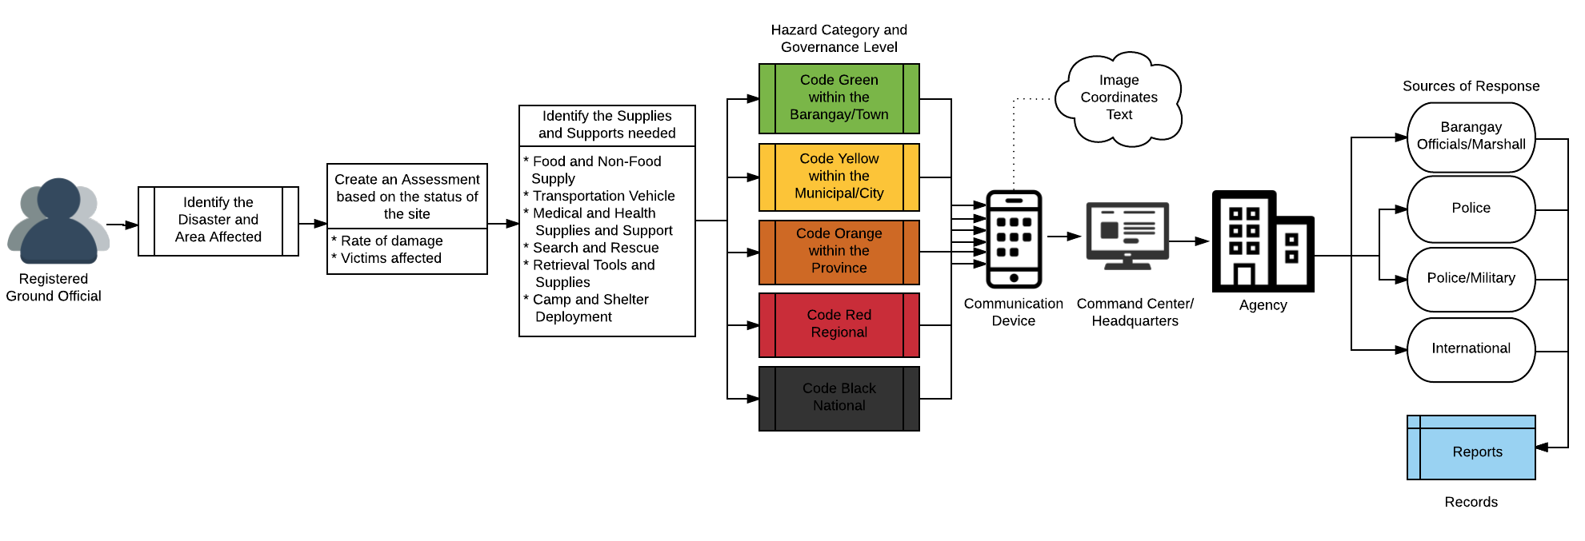

**Disaster Assessment Method (LGU level)**

Step 1: *Identify the disaster*

* Flash-floods
* Landslides
* Blocked Roads
* Wild Fires
* Epidemics
* Volcanic Eruptions
* Bridges Collapsed
* Infrastructure Collapsed
* Technical Accidents

Step 2: *Determine the rate of damage*

* Normal – Medium – Emergency

Step 3: *Identify the victims affected*

* Male Victims
* Female Victims

Step 4: *Assessment on the status of the area (Affected – Still Accessible – Unable to determine)*

* Access to basic domestic needs (food/water/health/shelter)
* Communication Lines
* Power lines
* Transportation
* Vital Infrastructures

Step 5: *Identify the Relief Services and Assistance required on responding*

* Search and Rescue Team
* Transportation Vehicles (Land/Air/Water)
* Medical and Emergency Team
* Food and Non-Food Supplies
* Camp and Shelter
* Emergency Telecommunications
* Engineers
* Security Personnel

Step 6: *Pin the location using Geographic coordinates*

Step 7: *Take an image of the present situation*

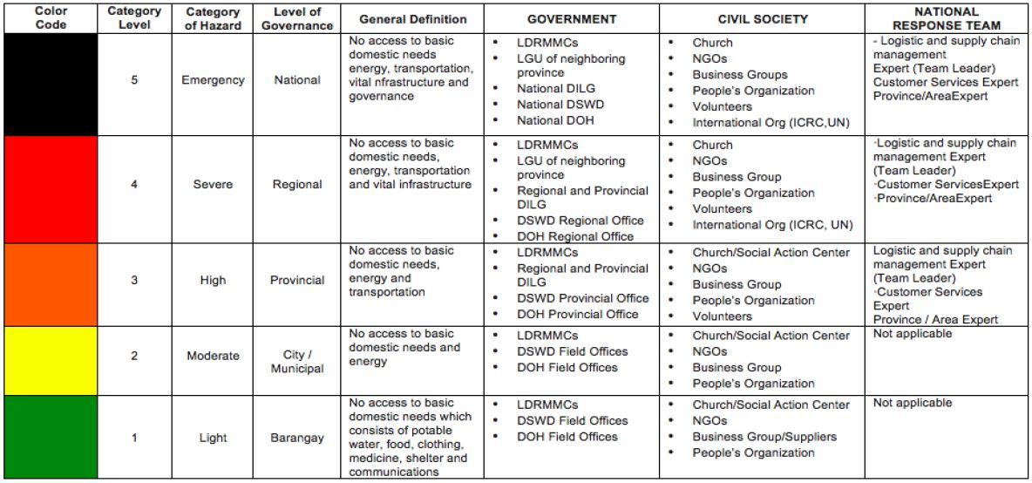

Figure 1 Assessment Table

Step 8: *Declare alert level system on affected area based on evaluated assessments*

*Code* ***GREEN*** *-------* Barangay Development Council, if one barangay is affected by a natural calamity or human-induced disaster

*Code* ***YELLOW*** *------* City/Municipal DRRMC, if 2 or more barangays are affected

*Code* ***ORANGE*** *------* Provincial DRRMC, if 2 or more cities/municipalities are affected

*Code* ***RED***------------- Regional DRRMC, if 2 or more provinces are affected

*Code* ***BLACK***--------- NDRRMC, if 2 or more regions are affected

***Sub-Headquarter Structure***

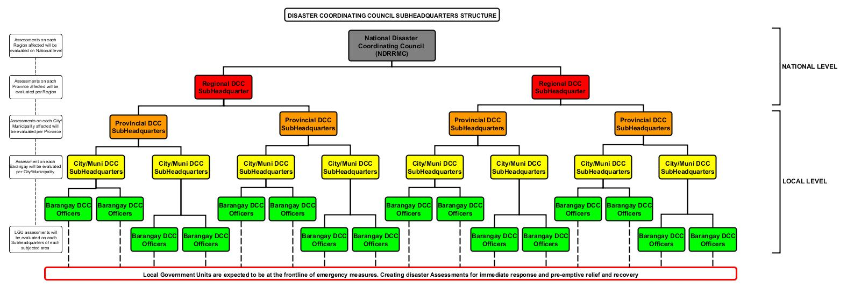

**Project Background**

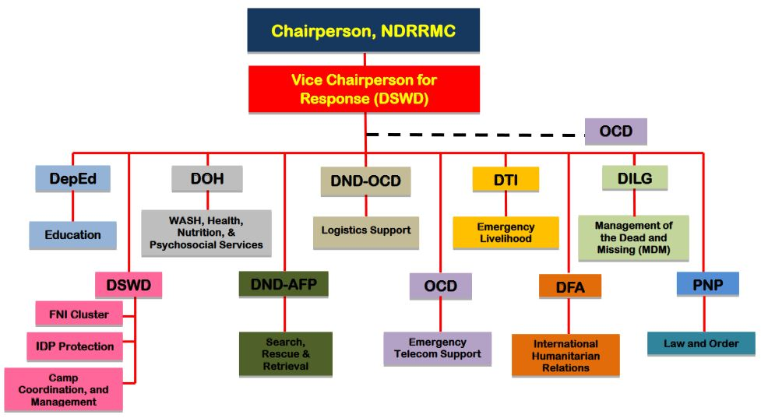

Figure 2 Organizational Chart of Response Cluster

Local government units are expected to be at the frontline of emergency measures in the aftermath of disaster to ensure the general welfare of its constituents. Based on the *1991 Local Government Code*.

Once a disaster hits, it’s not always the national government that acts first. The *National Disaster Risk Reduction and Management Council* (NDRRMC) is tasked to come up with a framework for *disaster risk reduction and management* (DRRM), as well as supervise preparation for, and responses to, natural calamities and human-induced disasters.

As first responders, they should be proactive in performing disaster-related activities, from preemptive evacuation to the restoration of people's livelihood.

Every LGU should also create a *Local Disaster Risk Reduction and Management Plan* (LDRRMP) covering 4 aspects of DRRM as specified in [NDRRMC's framework](http://www.ndrrmc.gov.ph/attachments/article/227/NDRRMFramework.pdf), namely: *disaster preparedness, response, prevention and mitigation, and rehabilitation and recovery*.

These LDRRMPs should be consistent with the [National DRRM Plan](http://www.ndrrmc.gov.ph/attachments/article/567/Signed_NDRRMP.pdf), and be implemented by Local Disaster Risk Reduction and Management Offices in every province, city and municipality in the country.

Republic Act 10121, the enabling law of NDRRMC, also provides for local DRRM councils, and specifies levels of coordination between NDRRMC and the local councils. The workflow and coordination is supposed to ensure and facilitate quick response *before, during,* and *after* disaster situations.

***Roles of the local government officials during disasters***

*Provincial Governors and City/Municipality Mayors*

* Carry out such emergency measures as may be necessary during, and in the aftermath of, man-made and natural disasters and calamities
* Submit a report when unexpected events and situations arise at any time during the year, particularly when man-made or natural disasters or calamities affect the general welfare of the city, province, region or country

*Provincial and City/Municipal Councils*

* Provide relief services and assistance for victims during and in the aftermath of said disasters or calamities and their return to productive livelihood following said events;
* Adopt measures to protect the inhabitants of the city from the harmful effects of man-made or natural disasters and calamities

*Other Local Officials*

* Be at the frontline of delivery of services related to their line of work, particularly during, and in the aftermath of, man-made disasters and natural calamities

***Composition from Local to National Councils***

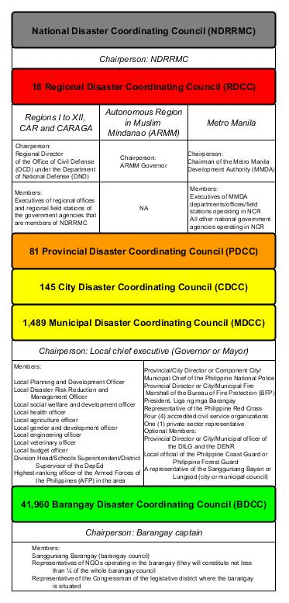

***Coordination between NDRRMC and local councils***

The following take the lead in certain scenarios:

* Barangay Development Council, if one barangay is affected by a natural calamity or human-induced disaster
* City/Municipal DRRMC, if 2 or more barangays are affected
* Provincial DRRMC, if 2 or more cities/municipalities are affected
* Regional DRRMC, if 2 or more provinces are affected
* NDRRMC, if 2 or more regions are affected

**Objectives:**

Our project team will provide proof of concepts on determining the alert level of risk from local to national level through forming a disaster assessment form. In addition is the structure of command and control sub-headquarters to be deploy per government level that will evaluate the assessments per affected City, Province and Region.

**Project Scope**

* Identify the disaster and area affected
* Identify the hazard category and governance level
* Determine the rate of damage and victims affected
* Deploy relief services and support functions
* Communication between the respondents
* Centralized disaster assessment management system

**Limitations**

* Assessing volunteer must be registered as Disaster Coordination Council Officer per area of coverage
* Network Connectivity for transmission of data to sub-headquarters

1. **Review of Related Literature**



A proprietary mobile app which uses wireless mesh networking (Bluetooth or Wi-Fi) to enable smartphones communicate even without network or Internet connection.

Traditionally, users sent messages to each other through data or Wi-Fi networks. The messages are sent through a mobile network to a hotspot or cell phone tower. The data sent through to these data towers or Wi-Fi hotspots are then relayed through a centralized network and eventually the messages or data is received. During all this data transfer period, your VPN is tracked. Though you can use a VPN service to protect your mobile data, information about your network can be tracked. Unlike most chatting apps, the FireChat doesn’t rely solely on Wi-Fi or data – it doesn’t even need a hotspot or centralized mobile network to relay data. Instead, the app relies on peer-to-peer connections through wireless mesh networking via Bluetooth or Wi-Fi, technology built in the phone. If the FireChat users are within 100 feet of each other, they can connect and share messages.

FireChat is a free mobile app that works where other apps can’t: when there are no cell networks or Internet access. How is that possible? The app uses the radios inside phones to let users connect to each other for free, via Bluetooth and direct Wi-Fi, without going through a telecom operator. The more people use it, the better it gets. When there is no Internet, for example at a music event, on the train, on a plane, or at a sports game, you can continue chatting and sharing pictures with the people around you. This is called “The Internet of Us”. It’s peer-to-peer networks gone mainstream, just like peer-to-peer to share music.



Eden is a flexible humanitarian platform with a rich feature set which can be rapidly customized to adapt to existing processes and integrate with existing systems to provide effective solutions for critical humanitarian needs management either prior to or during a crisis. Sahana Eden’s features are designed to help Disaster and Emergency Management practitioners to better mitigate, prepare for, respond to and recover from disasters more effectively and efficiently. Sahana Eden can provide valuable solutions for practitioners in Emergency Management, Humanitarian Relief and Social Development domains.

Sahana Software was initially developed by members of the information technology (IT) community in Sri Lanka to provide solutions for the relief effort following the 2004 Indian Ocean Tsunami. Sahana Eden is the latest evolution of this software and provides a solution to manage organizations, people, projects, inventory and assets as well as collecting information through assessments and providing situational awareness through maps. Sahana Eden can be accessed from the web or locally from a flash drive, allowing it to be used in environments with poor internet. Local & Web versions can be configured to synchronize to allow data to be shared between them. Sahana Eden is a project of the Sahana Software Foundation, whose mission is: To help alleviate human suffering by giving emergency managers, disaster response professionals and communities access to the information that they need to better prepare for and respond to disasters through the development and promotion of free and open source software and open standards. The project is supported by a voluntary community of Disaster Management practitioners, students, academics and companies. This community can provide a basic level of support to help you deploy and configure Sahana Eden. There are also companies, such as AidIQ, who provide professional services to customize and support Sahana Eden.

1. **Technical Background**

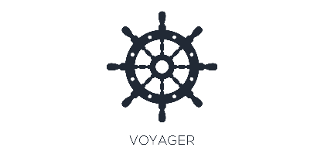

The Command & Control System will be made by the project team using a different software. The team will be using Laravel, a framework that intended for the development of web applications following the model-view-controller (MVC) architectural pattern. It also allows the team to have an easy time developing and accessing databases, which will be needed in the system since it intends to record all the accounts and reports that the users will be creating. In making the forms, the project team used JotForm. It is an online application that allows anyone to quickly create custom online forms. Its intuitive drag-and-drop user interface makes form building incredibly simple, and does not require to write a single line of code.

For hardware, the project team will be creating a website that would be accessible to both PC's or laptop and mobile phones; the team creates a different interface when users access the website using their mobile phones. For software, the users only need a web browser to access the website since it would be published on the world wide web, the only thing they need to get into the system is any web browser and a connection to the internet. The system will be updated regularly to ensure users would have an easy time accessing and browsing the website. For the network, the users will need an internet connection to access the website; the internet is a crucial part of the network between the system and users because the system will be on the world-wide web.

**Technical Requirements**

* Dedicated Server(s) (sub-headquarter dashboards)
* Handheld/Mobile Device(s) (Android supported platform)
* Telecommunication Network (Internet)
* Communication Device(s) (Radios and Repeaters)

1. **Methodology, Results and Discussion**

**Requirement Analysis**

*Function Requirements*

* The system supports users reports and can modify.
* The system administrator can edit or delete users reports.

*Non-Function Requirements*

* The system must be able to handle multiple reports a time.
* The system should support almost all the browsers, and most mobile devices.
* The system must provide users, the ground officials, 24/7 of service.

**Requirement Documentation**

*User Guide*

Describes what the system does, and how to use it. It must include installation instructions. It should be brief and informative. The project team is not required to offer training sessions for any users, only a demonstration session for the client, the NDRRMC.

*Maintenance/Programmers Guide*

A brief but informative guide which details key issues for anyone who may have to maintain the system. It should clearly describe what functionality is found in each class. The project team should be rigorous in their commenting of code to aid the construction of the maintenance guide and aid client readability.

**Description of the Prototype, where applicable**

A prototype is an initial formation of a product that demonstrates the basics of what a product will resemble, what the product will do, and how the product operates. It is not intended to be the final form; it is the unfinished version type of the product. It helps people to get a solid idea of what the product will be and adjust while it is still in concept mode.

After brainstorming with the professor and different clusters, the project team could gain more details and procedures that should consider in creating the system. Requirement gathering process was done by using a few strategies such as research and brainstorm. Researching and brainstorming on the process of NDRRMC is beneficial to the system and clear out numerous distinctions in regards to necessities about the system.

The project team made a working prototype of a website that serves as a dashboard for Law & Order. This prototype can be worked on both front-end (user) and backend (administrator). Every user must make an account that requires unique username and password. Its processes are to keep track of reports, and receiving and sending reports to others clusters.

1. **CONCLUSIONS AND RECOMMENDATIONS**

**Conclusion**

To conclude, the Command & Control System was developed for the NDRRMC. The said system serves users in a better way that it keeps proper records of users reports for security purposes. The project team could analyze the process of NDRRMC and could make a working prototype for users and system administrator. The project team created a website for the NDRRMC, that serves as a dashboard for Law & Order. In the backend, the database and forms were generated for the system administrator to view, create, update, and delete records of reports.

**Recommendation(s)**

*The project team would like to recommend the use of the working prototype of the proposed Command & Control System:*

* For students that will be interested for this study and would like to continue the research, the project team recommends them to enhance more the system.
* For researcher/s, the project team recommends them to make the design more enhance and attractive for the NDRRMC and users.
* The project would like to recommend to put some easy tip or make a manual guide for users that will automatically appear in the system to be user friendly.

1. **Appendices**

**System Diagrams**

***Over-all System Architecture of Response Cluster***

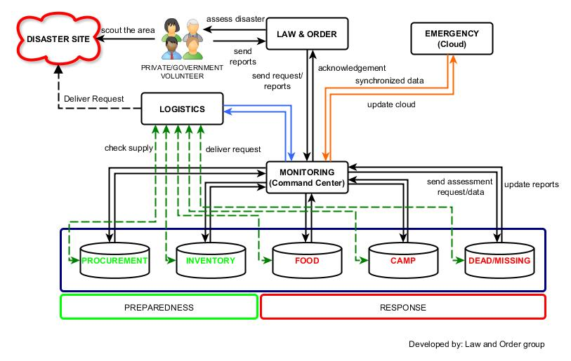

***Context-Flow Diagram (System)***

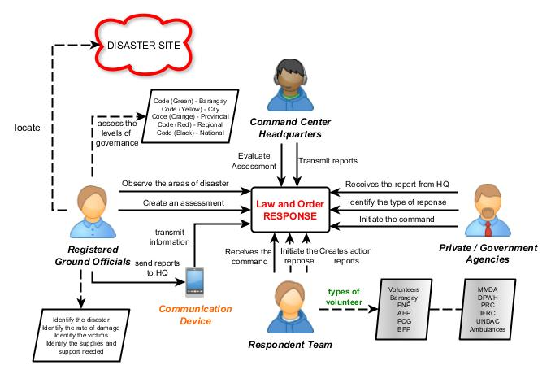

***Context-Flow Diagram (User)***

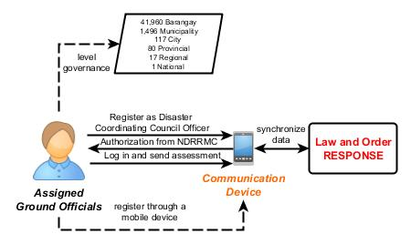

***Data Flow Diagram (System)***

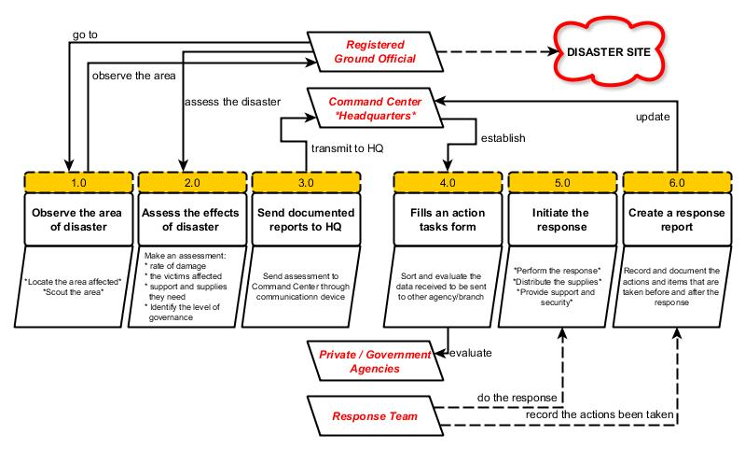

***Data Flow Diagram (User)***

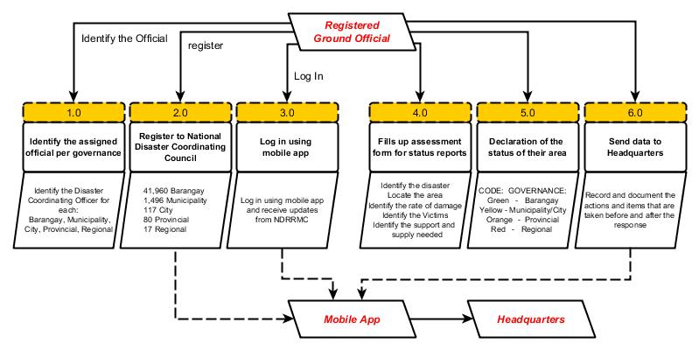

***User Case Diagram (System)***

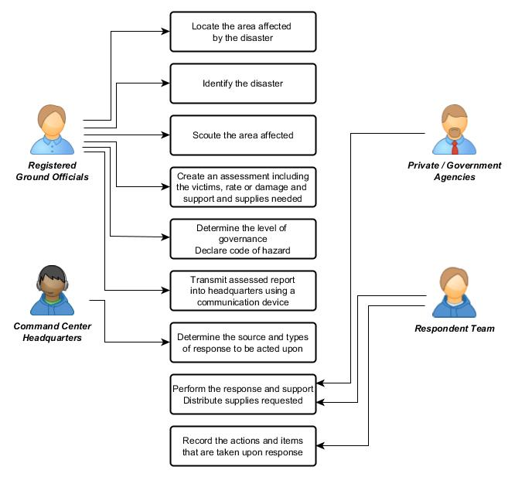

***User Case Diagram (User)***

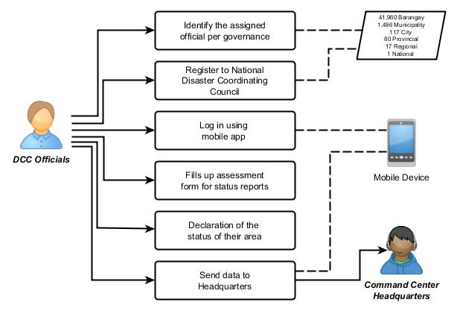

***Event Table***

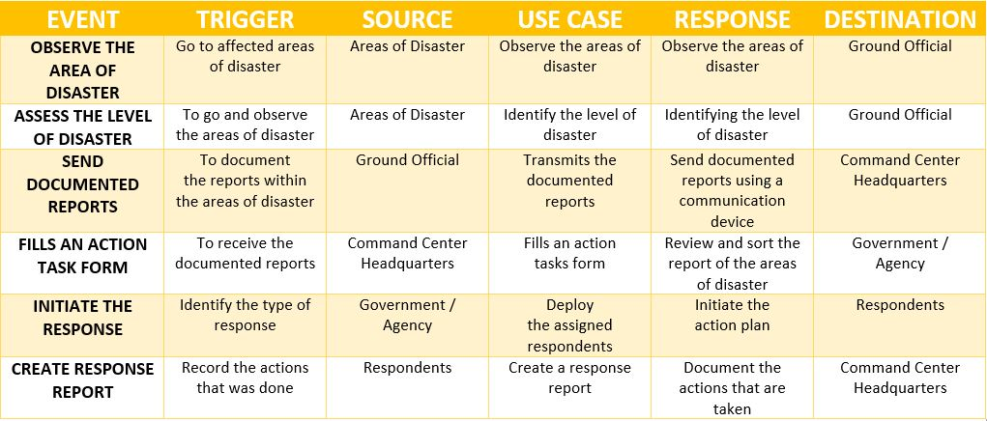

***Entity-Relationship Diagram***

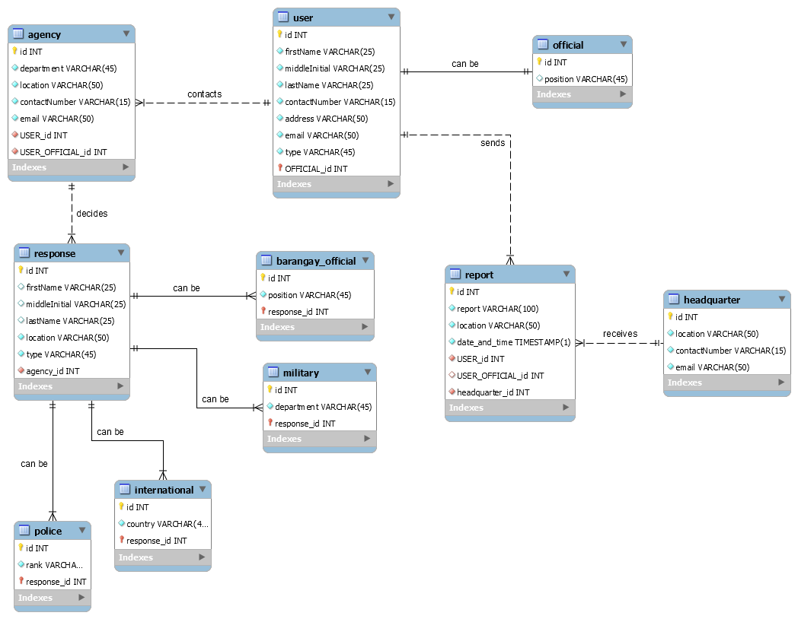

**Prototype Screenshots**

**Dashboard**

***Log In Page***

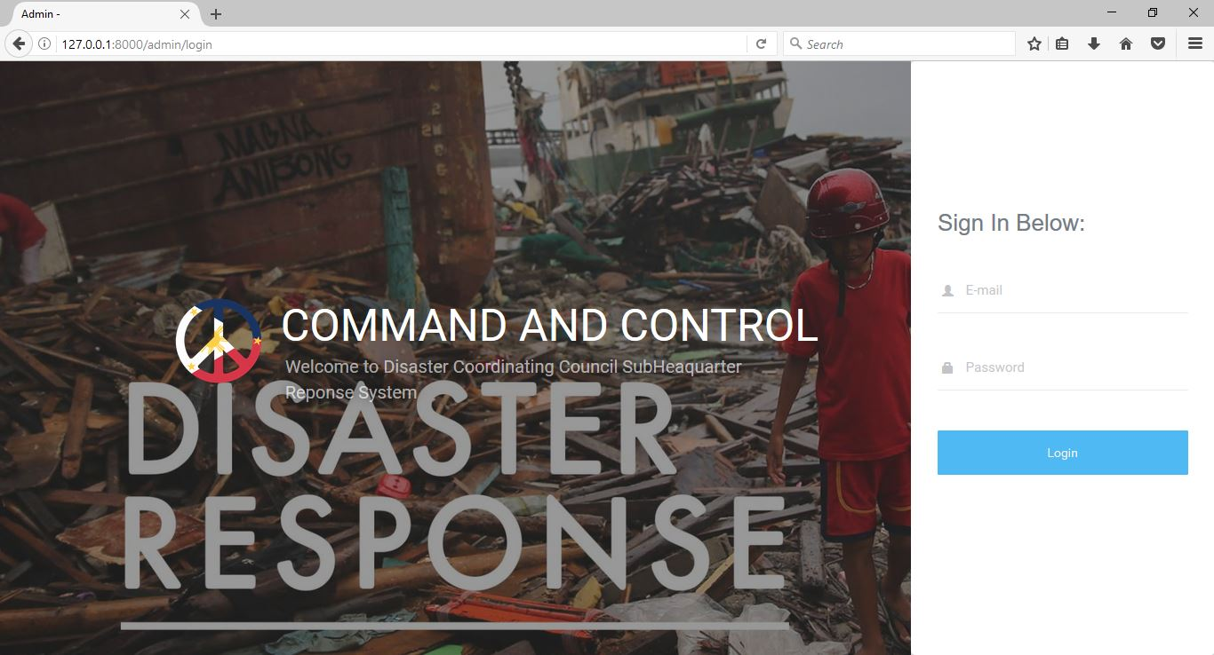

***Dashboard Homepage***

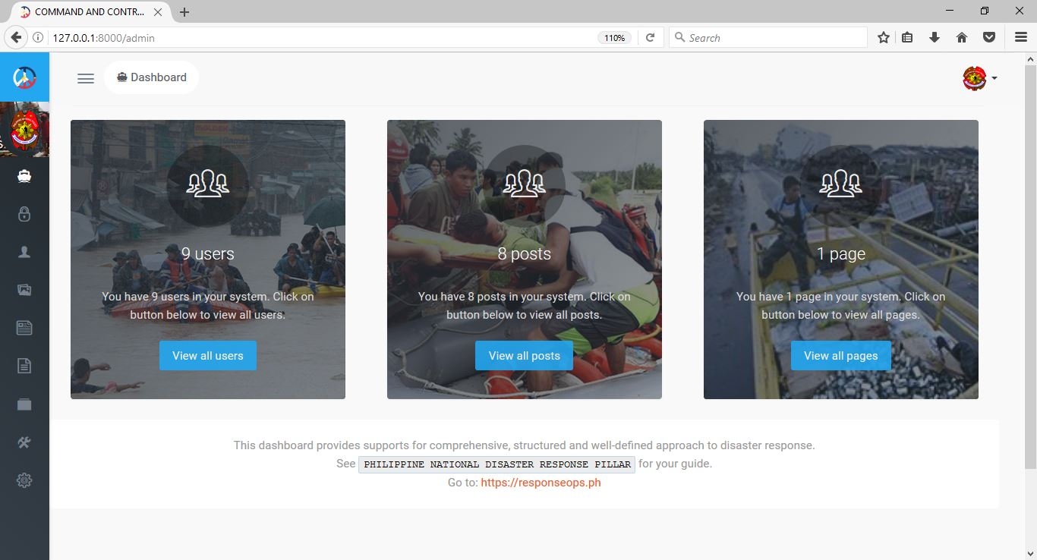

***Side Bar Menu***

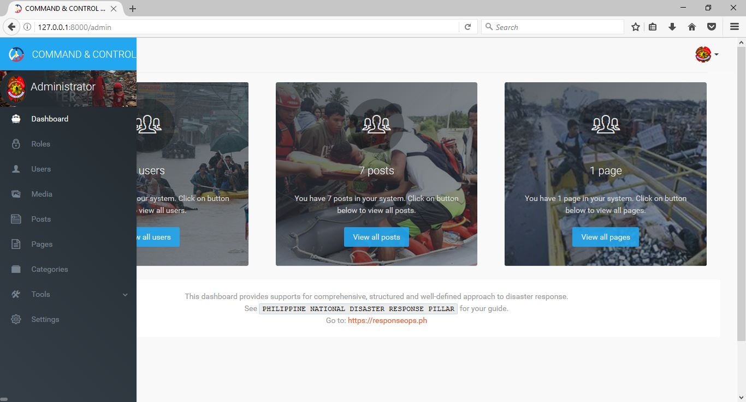

***Current User***

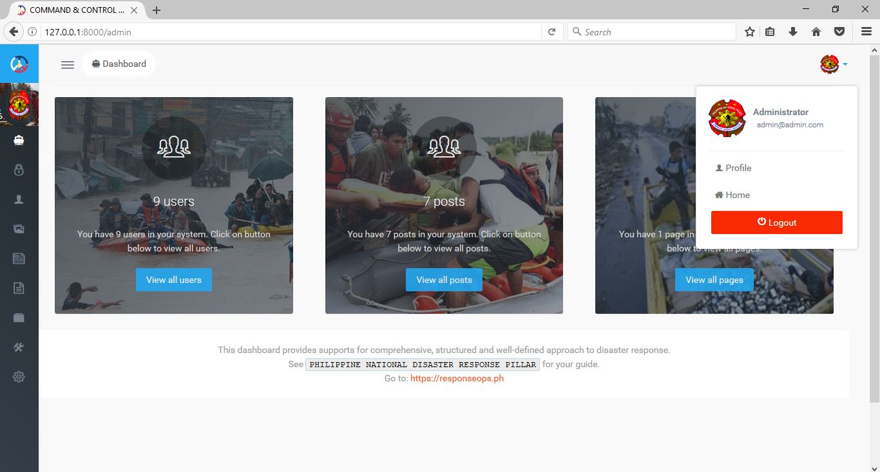

***Roles***

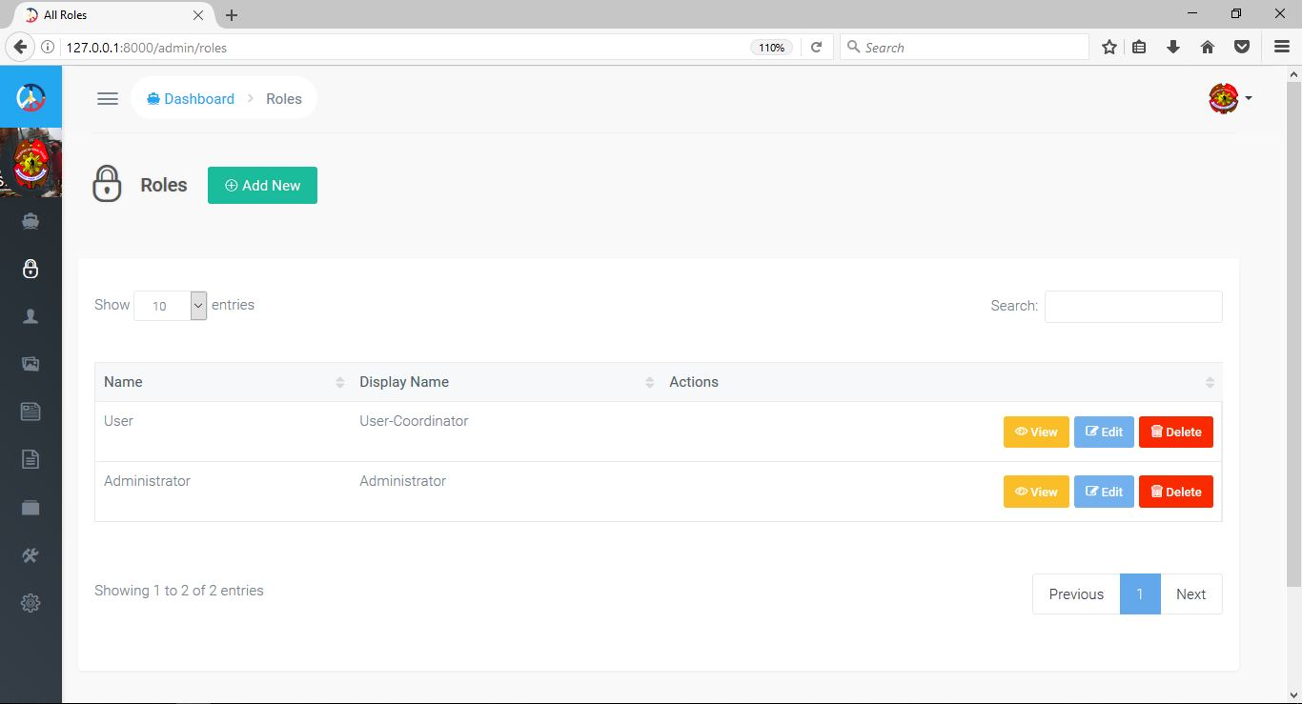

***Add new role***

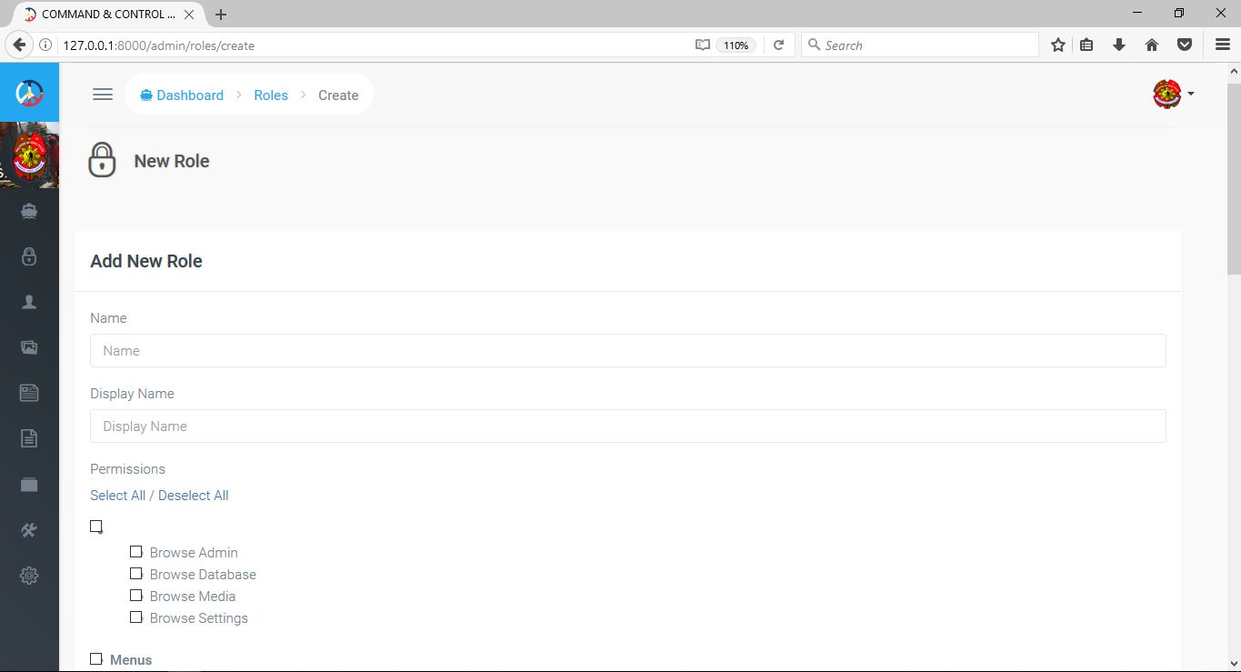

***Edit Role***

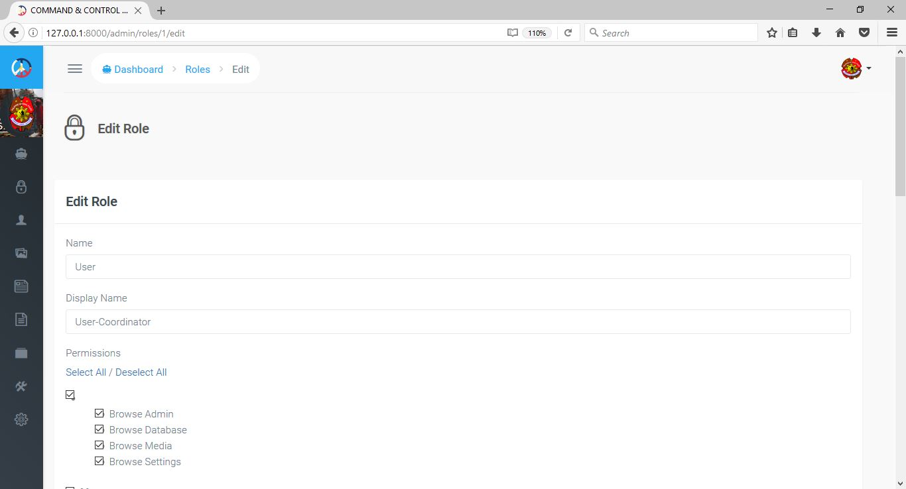

***Users***

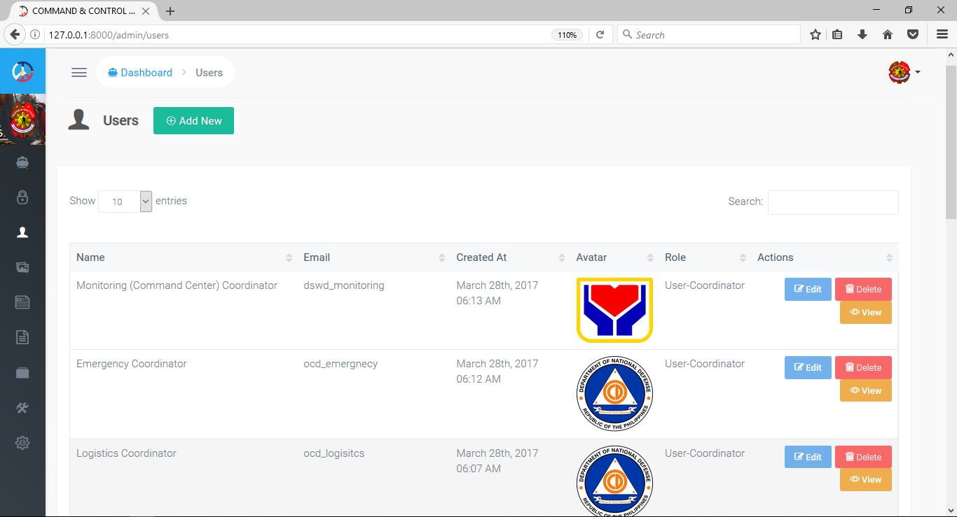

***Add new user***

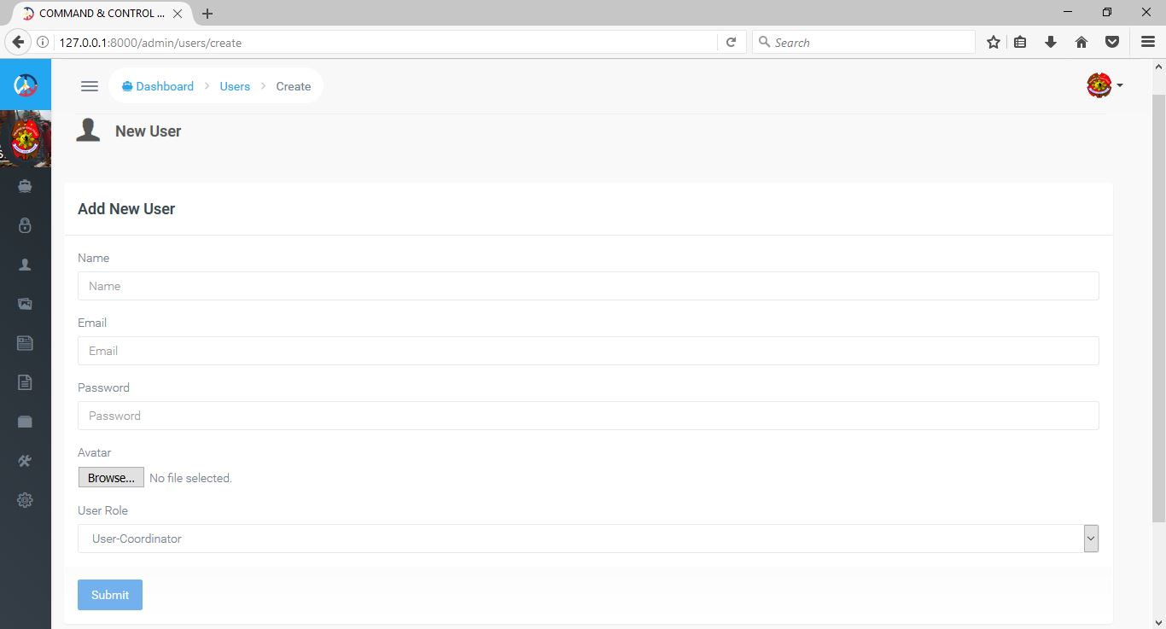

***Edit user***

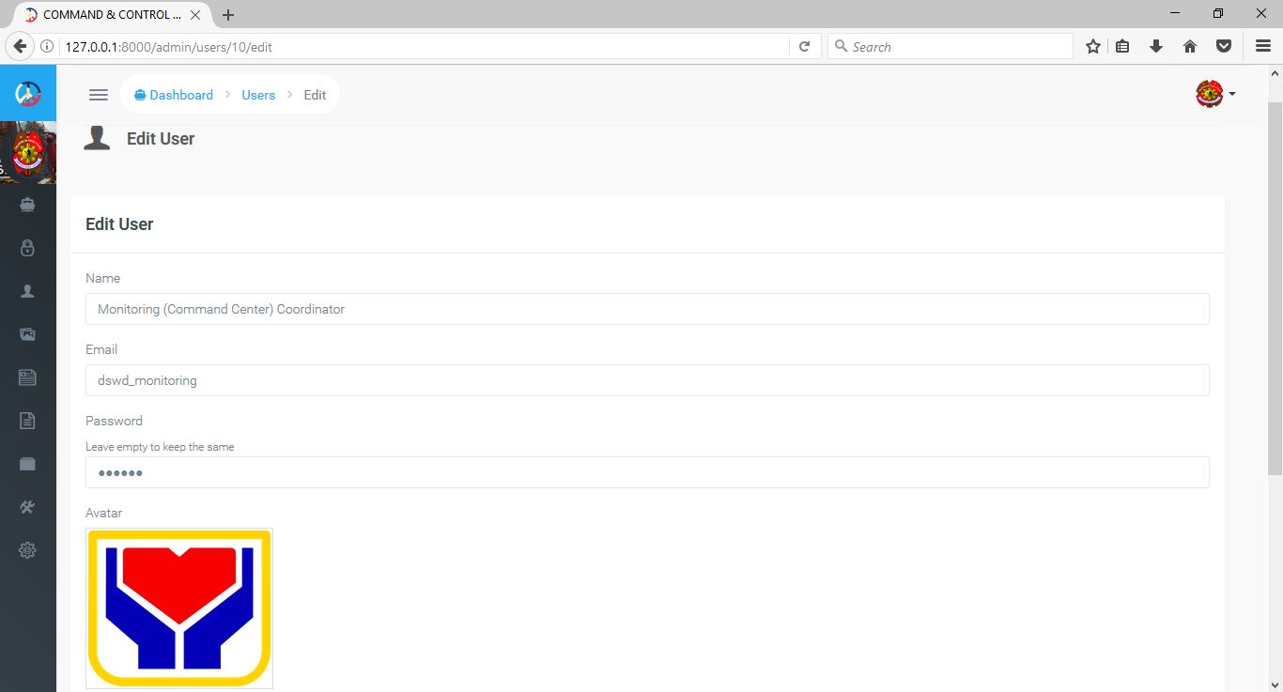

***Media resources storage***

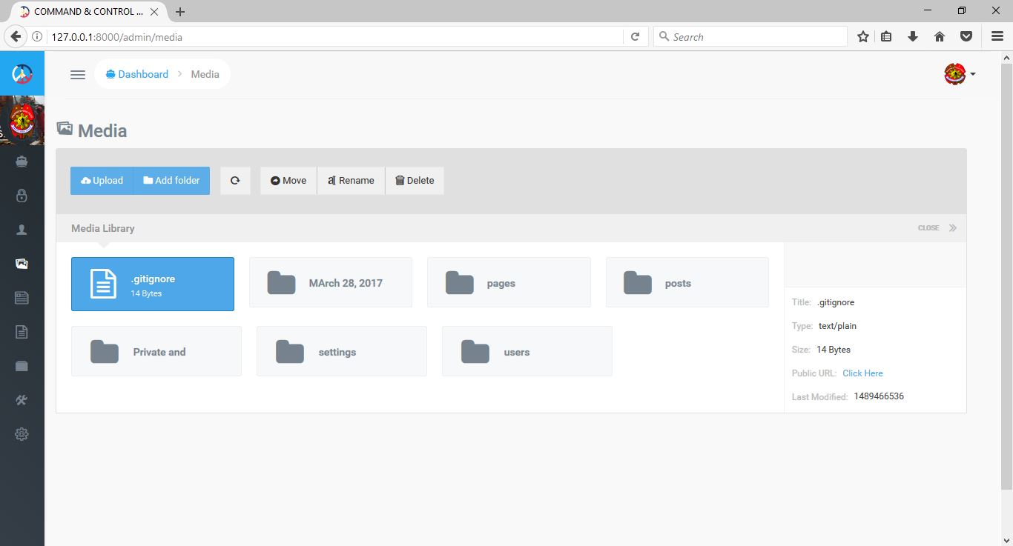

***Upload resources***

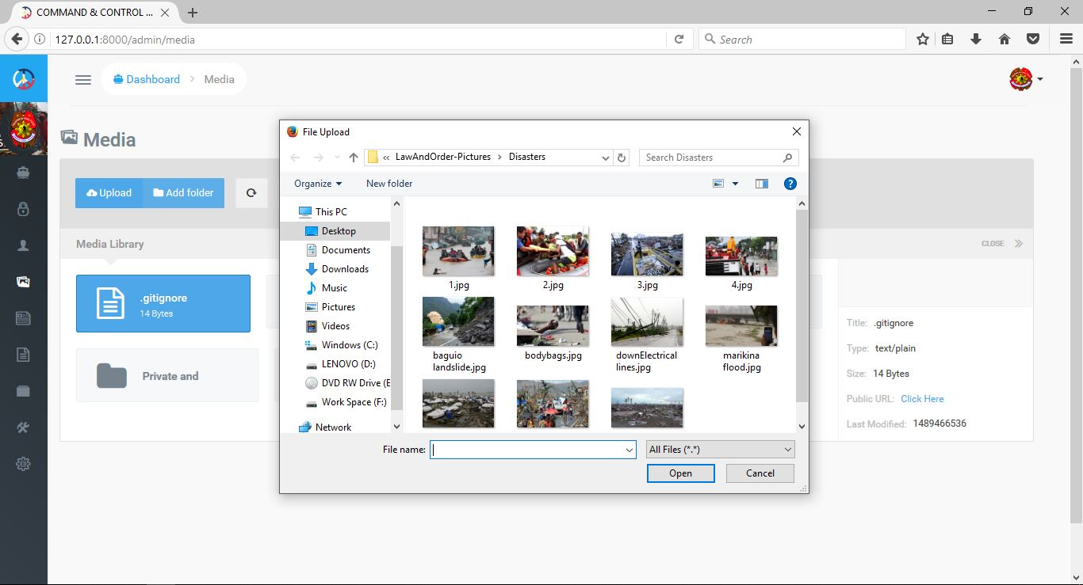

***Posts***

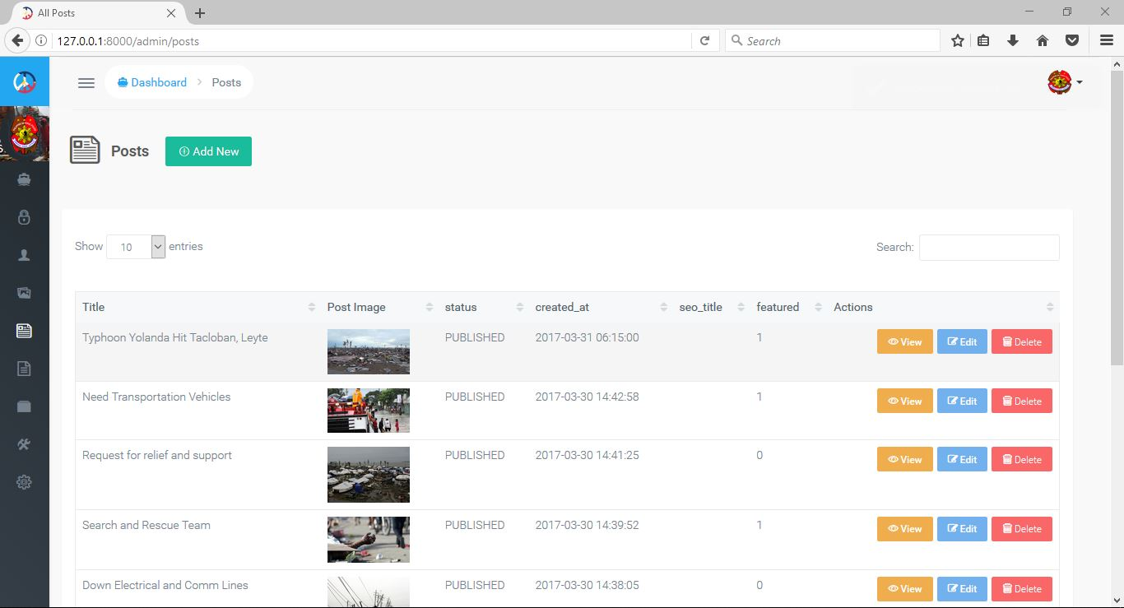

***Add new post***

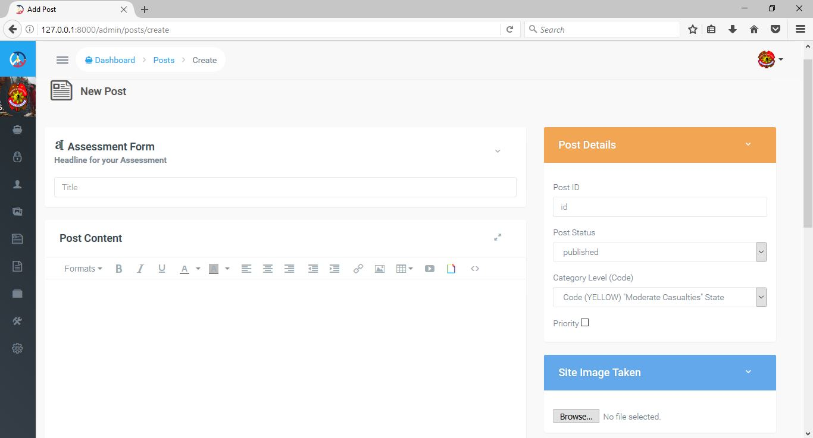

***Edit post***

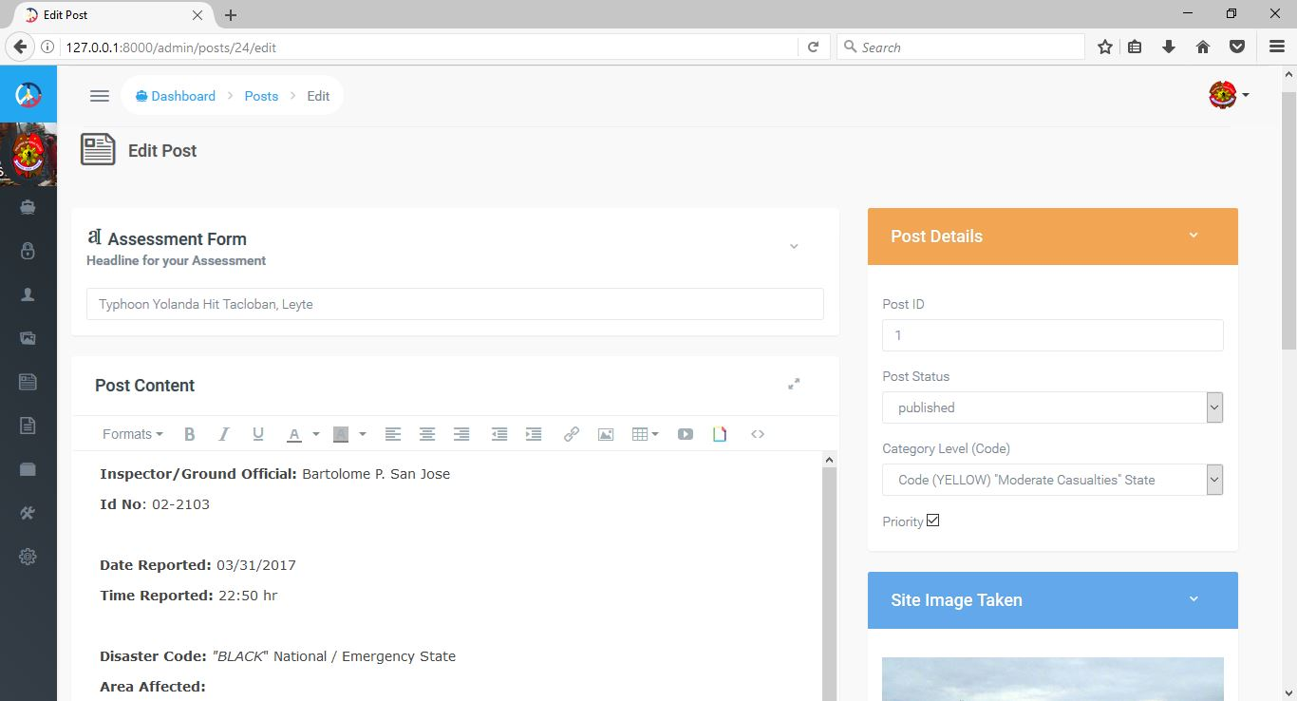

***Pages***

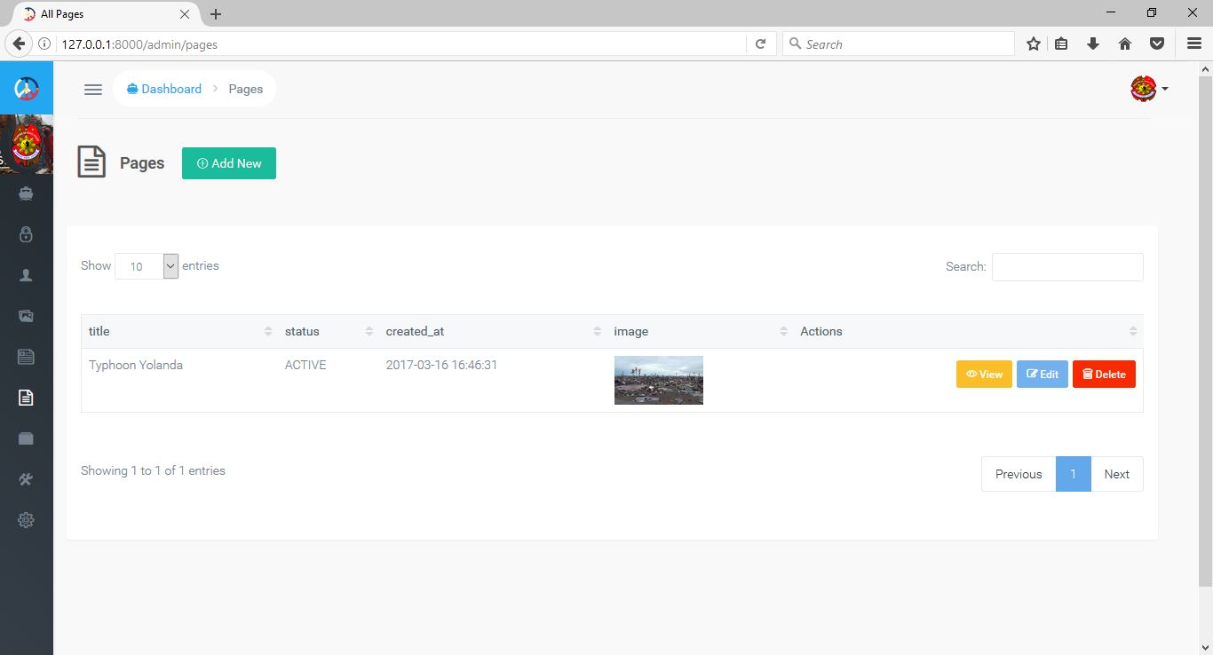

***Add new page***

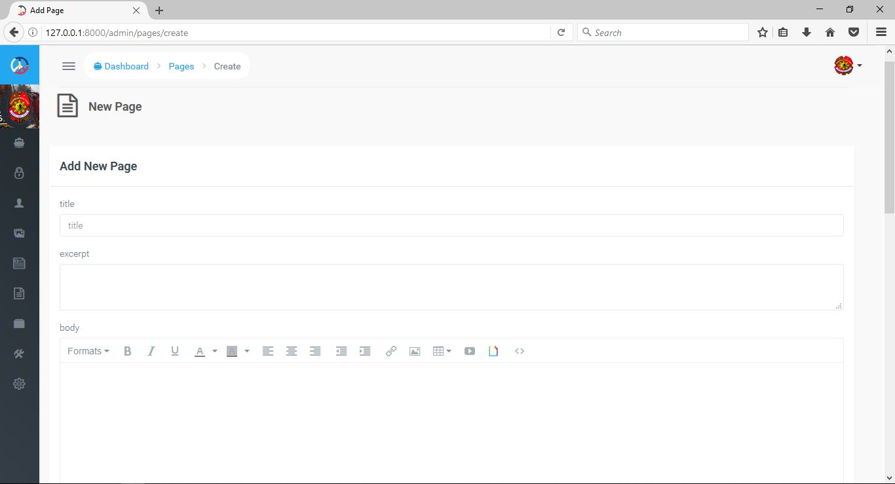

***Edit page***

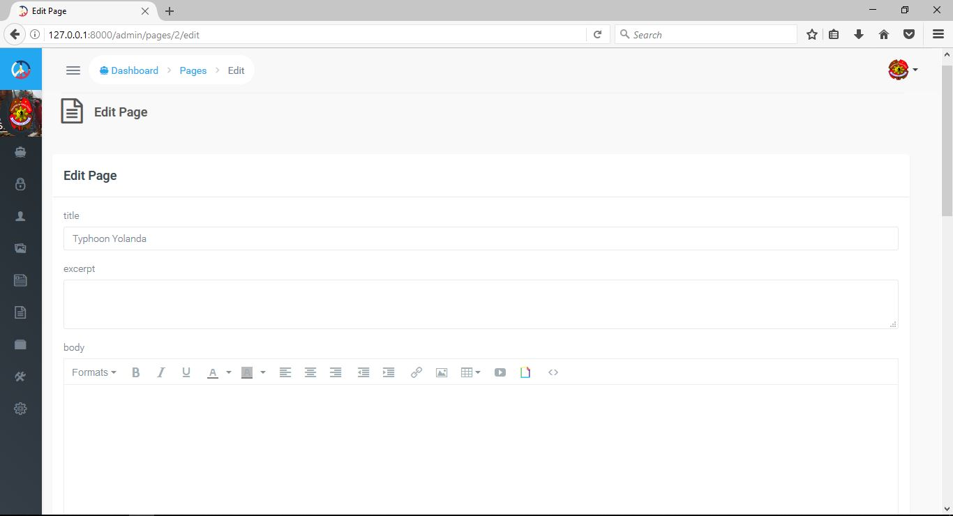

***Database (MySQL)***

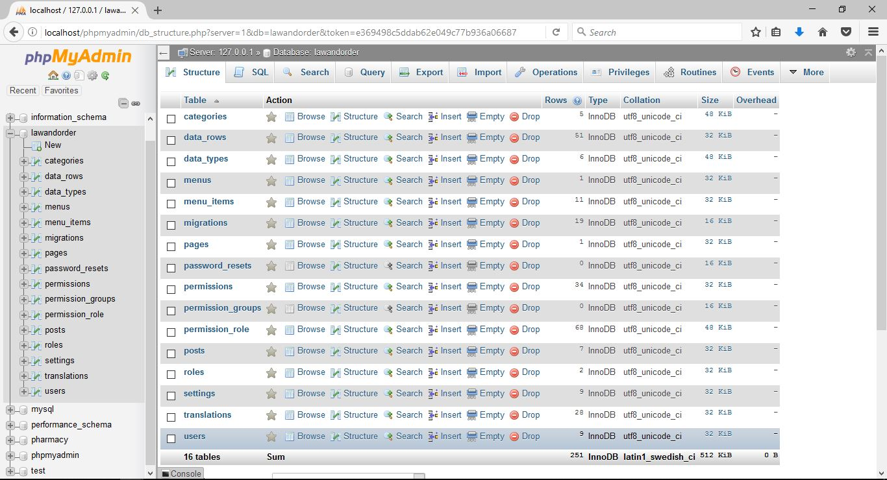

***Mobile (Registration)***

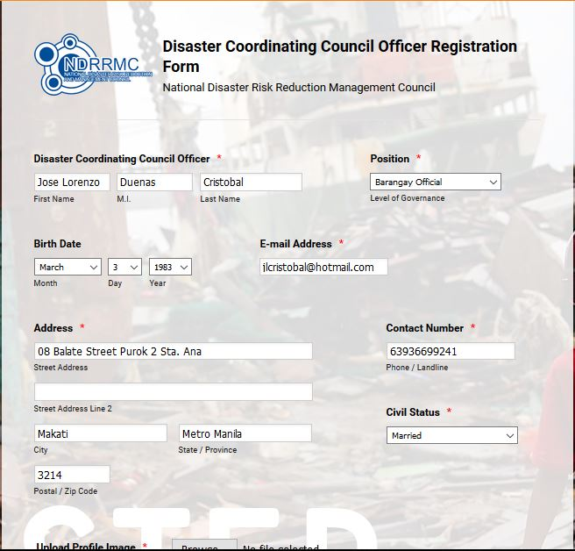

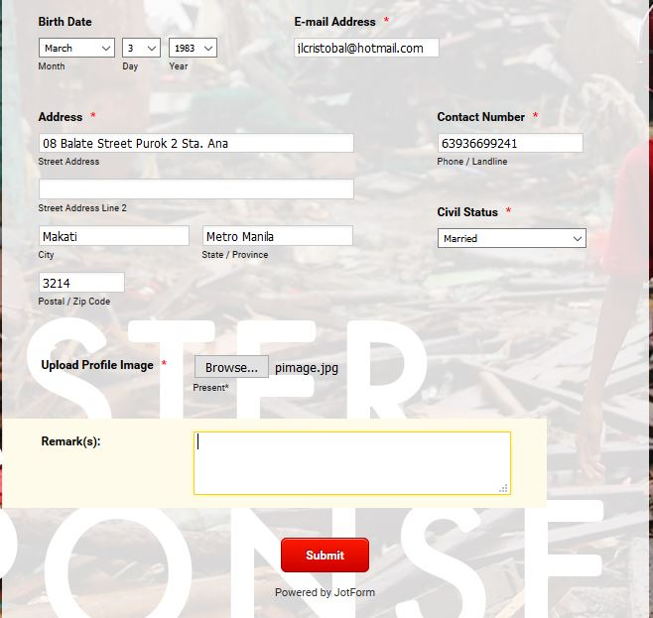

***LGU Disaster Assessment Form (Mobile)***

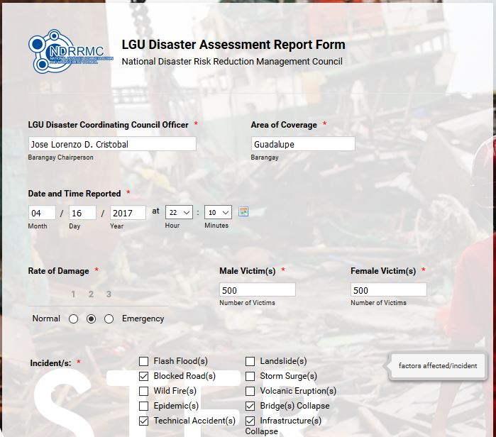

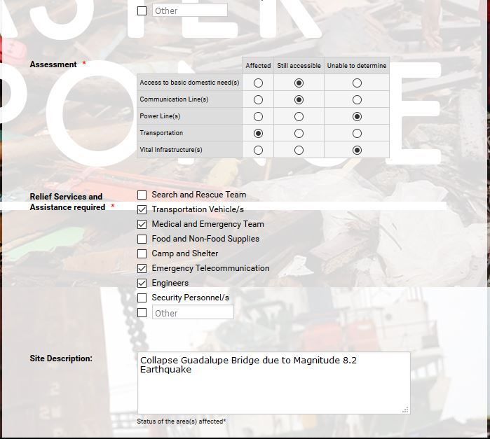

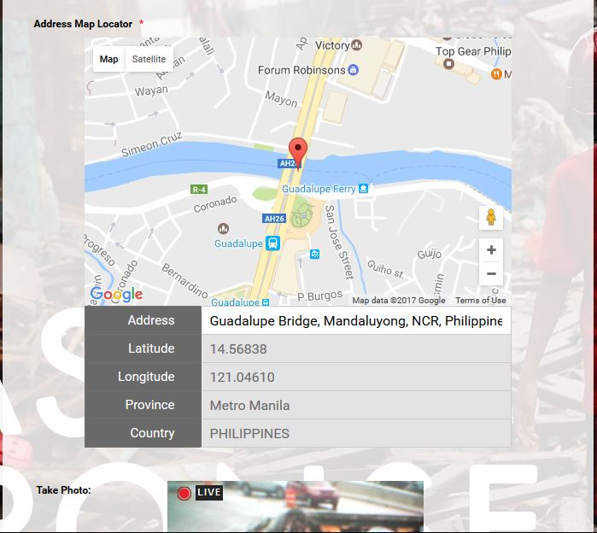

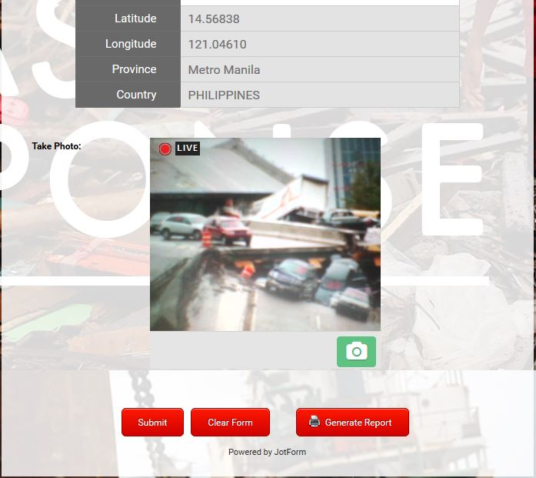

***Provincial/City/Municipal Disaster Assessment Form (Mobile)***

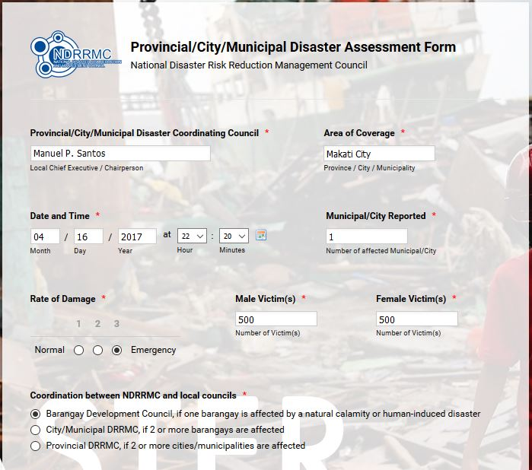

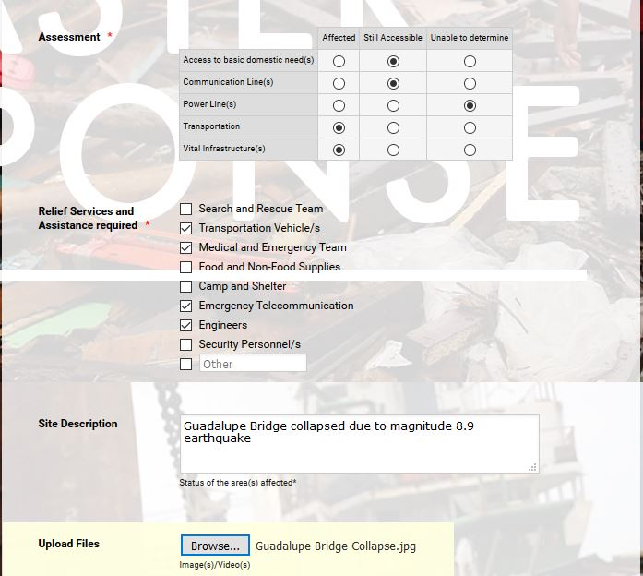

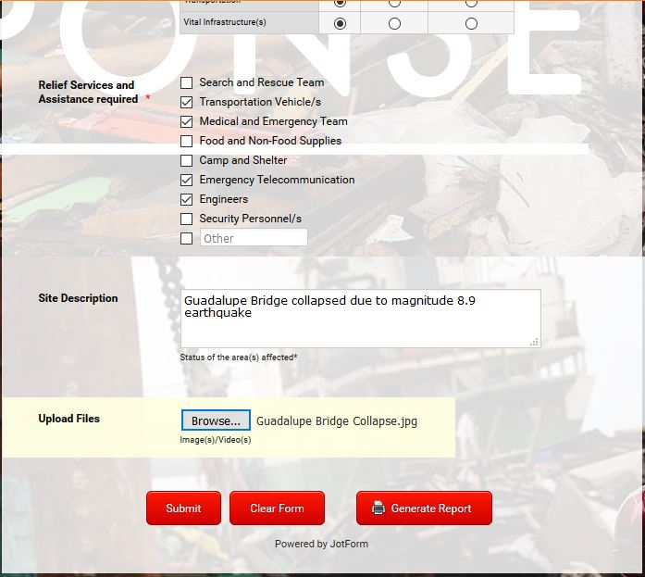

***Regional Disaster Assessment Form (Mobile)***

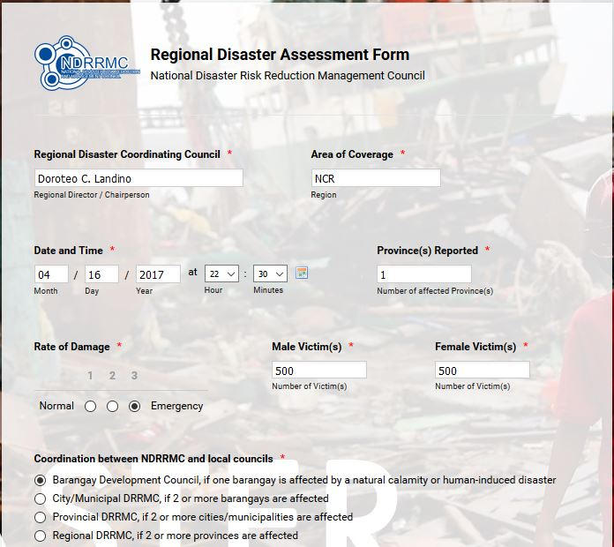

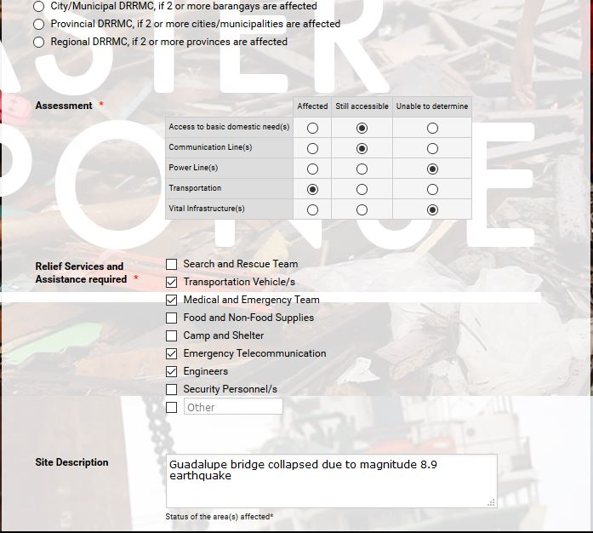

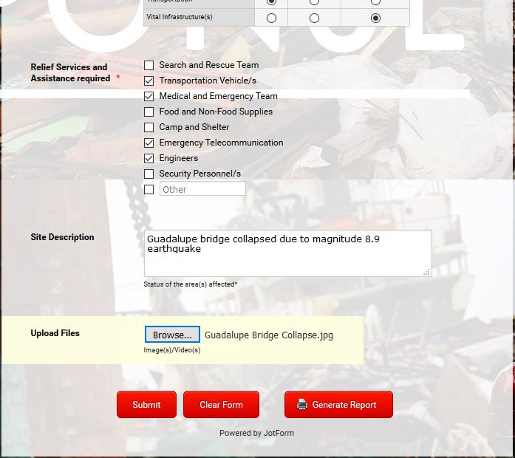

***National Disaster Assessment Form***

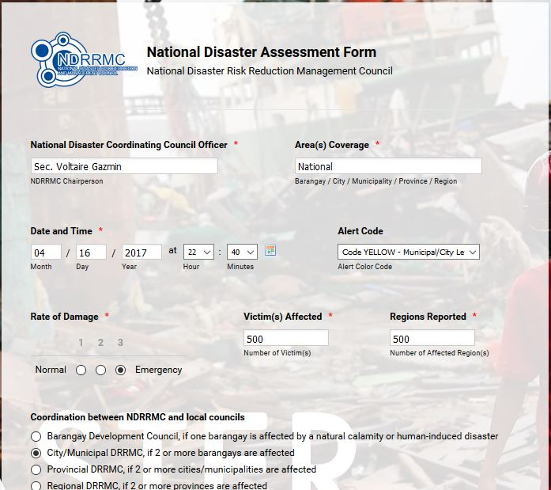

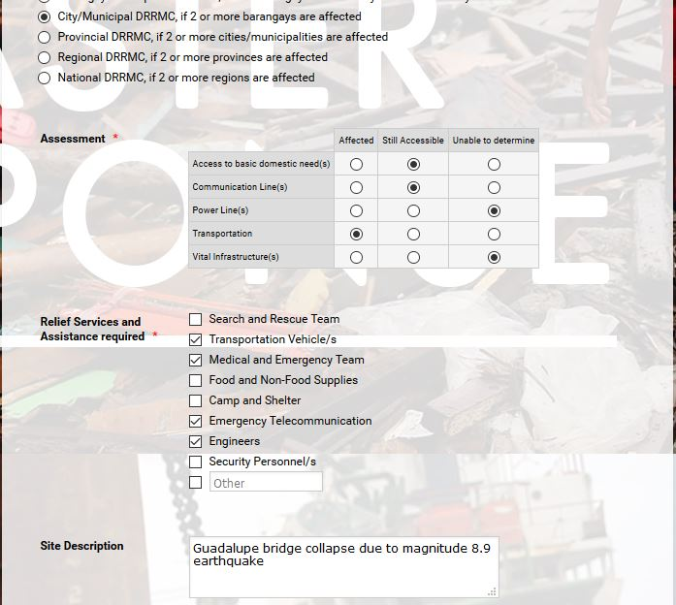

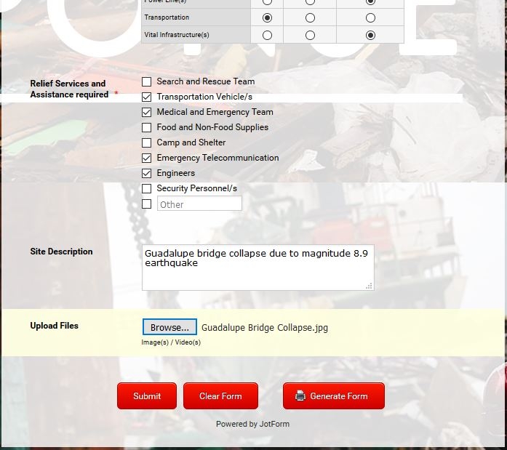

1. **Quality Assurance Checklist**

***User Interface (Dashboard)***

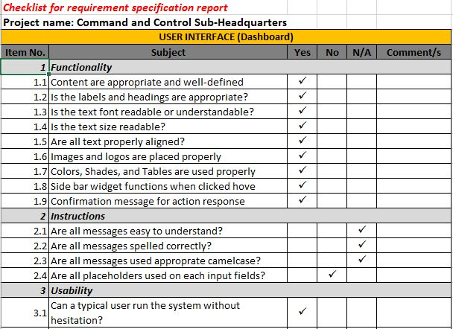

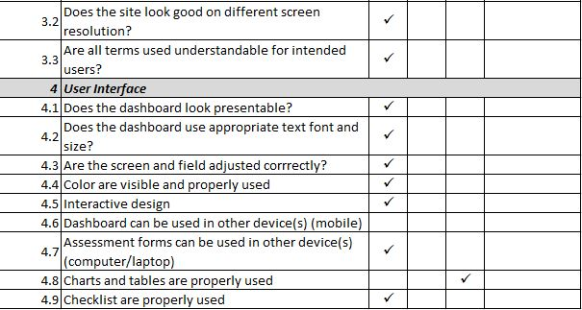

***Functionality (Dashboard)***

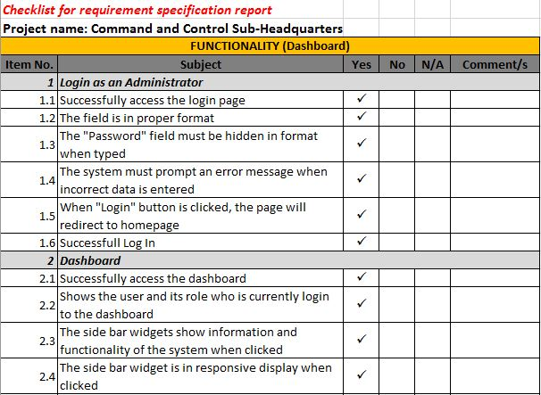

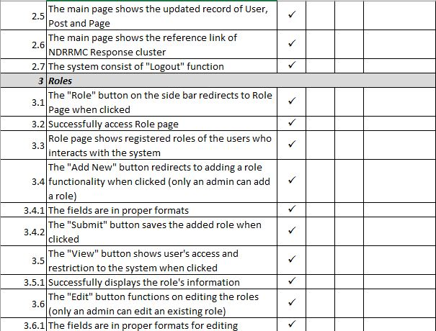

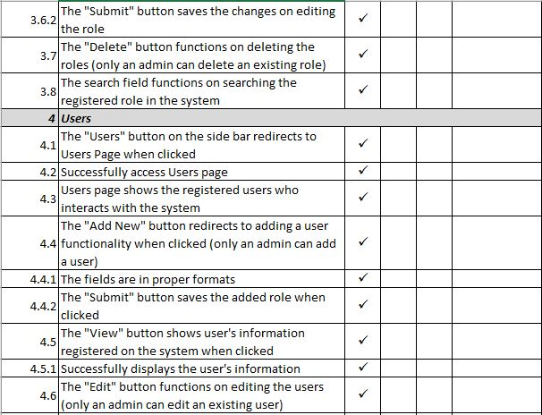

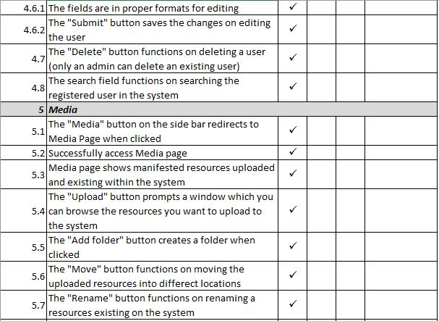

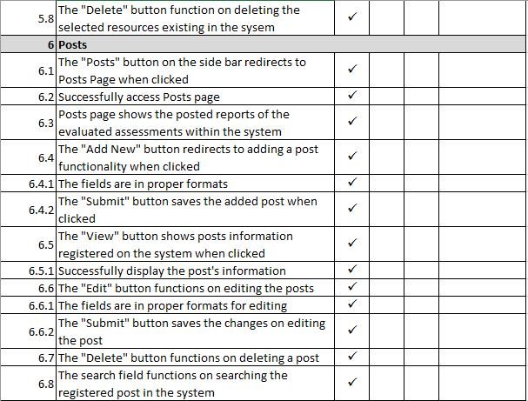

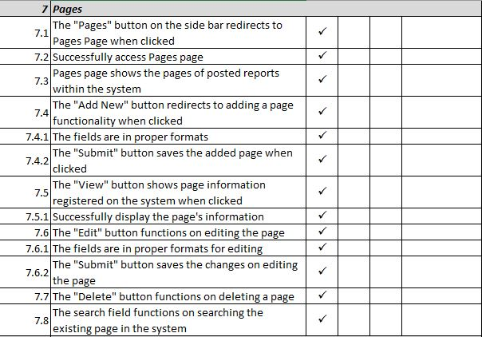

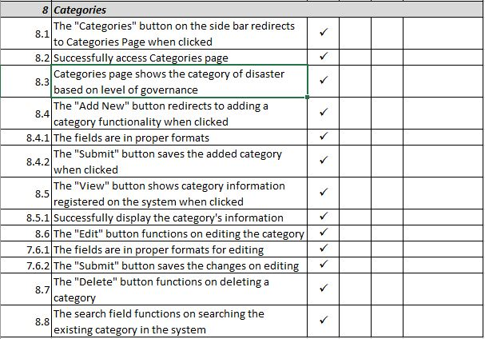

***User Interface (MobileApp)***

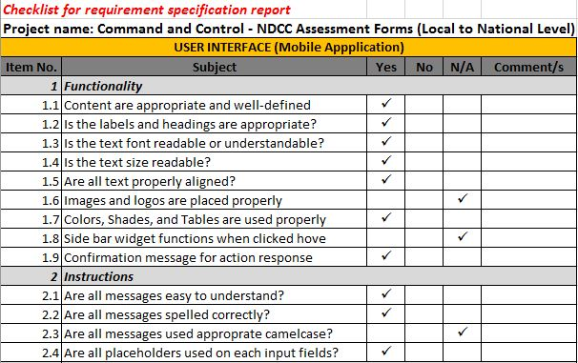

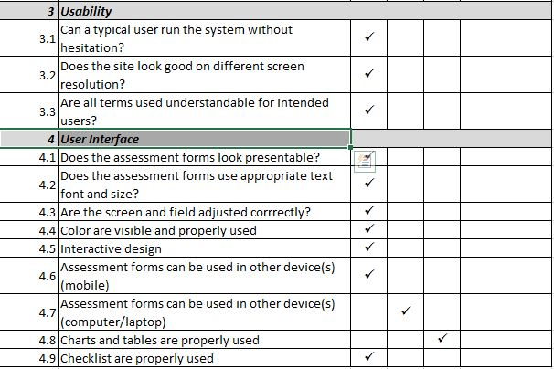

***Functionality (MobileApp)***

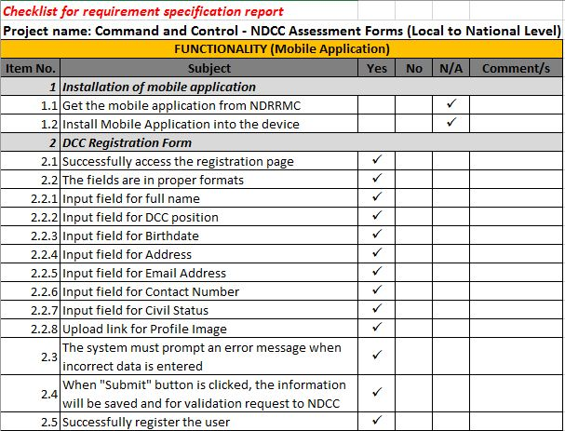

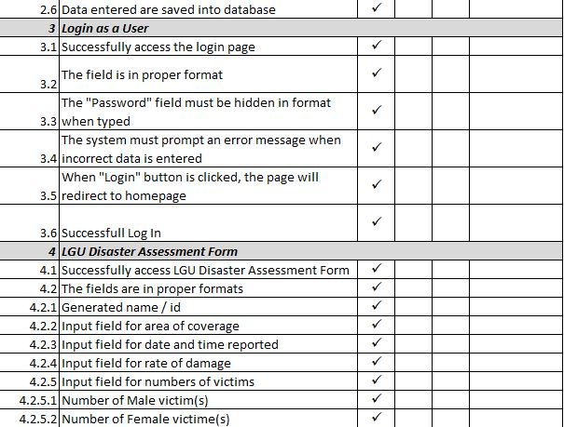

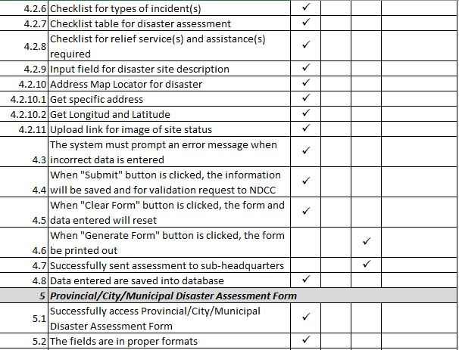

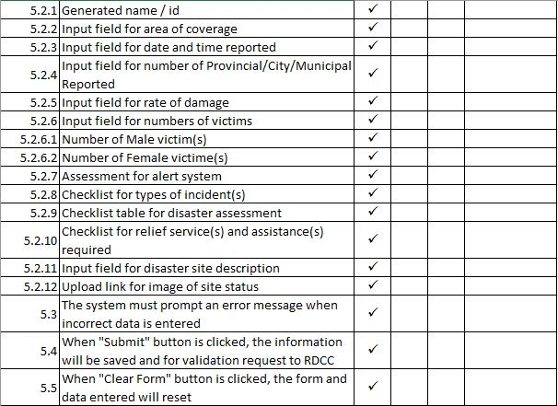

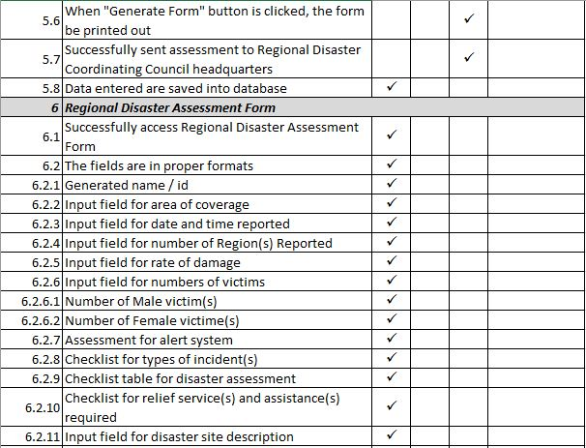

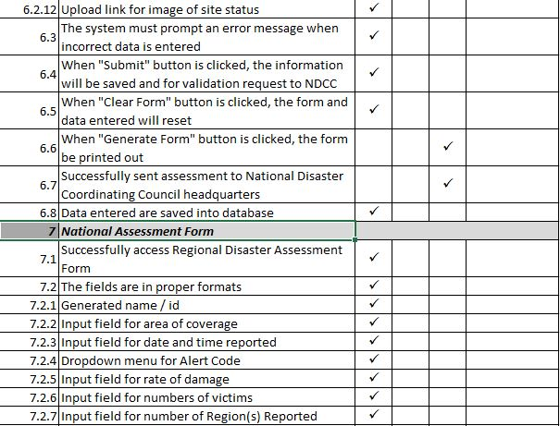

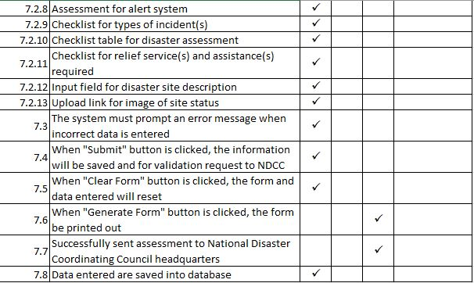

1. **Quality Test Cases**

***Login Dashboard***

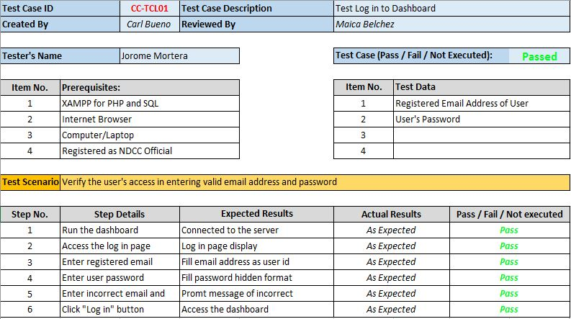

***Dashboard Functionalities***

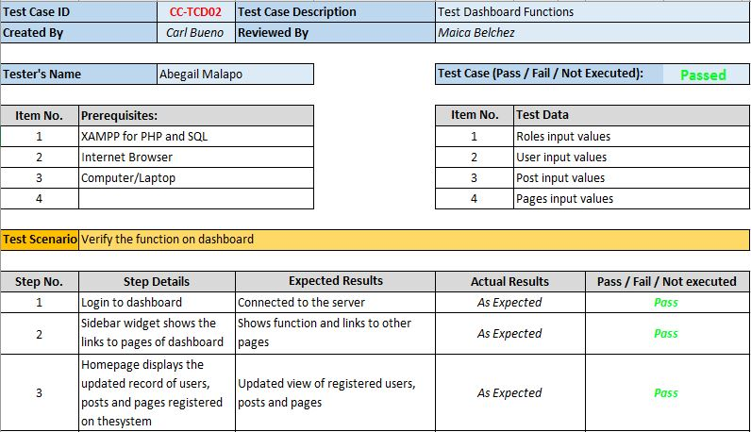

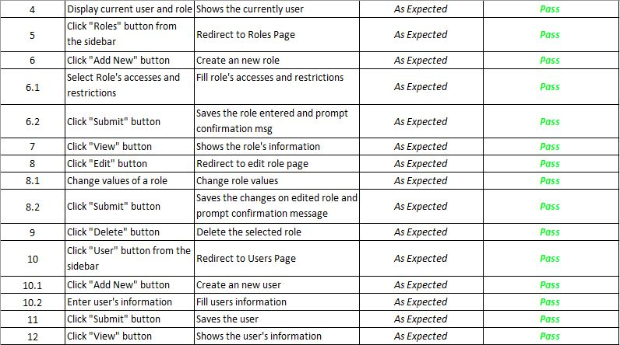

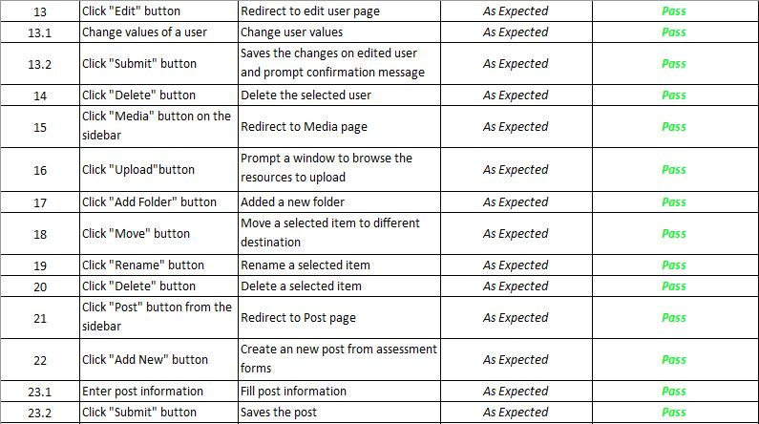

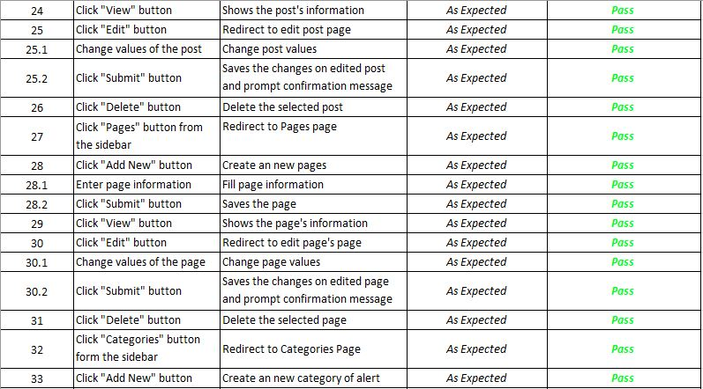

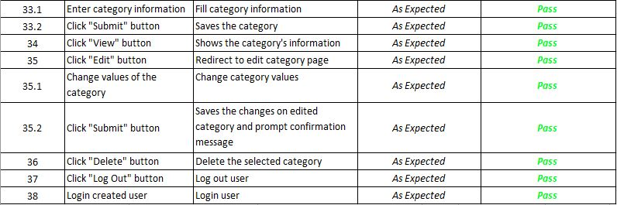

***Disaster Coordinating Council Officer Registration (MobileApp)***

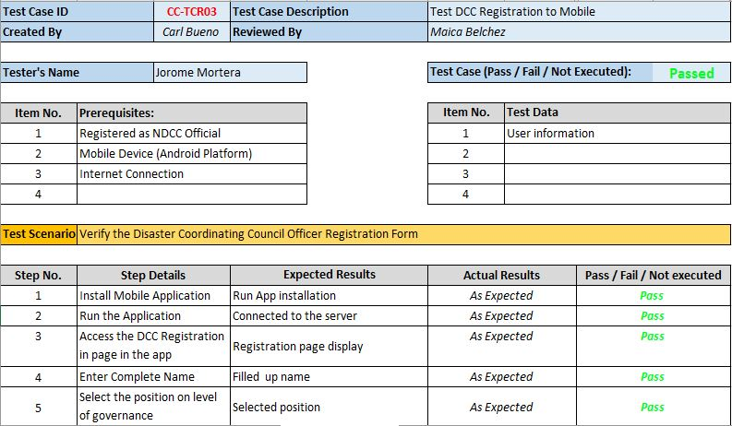

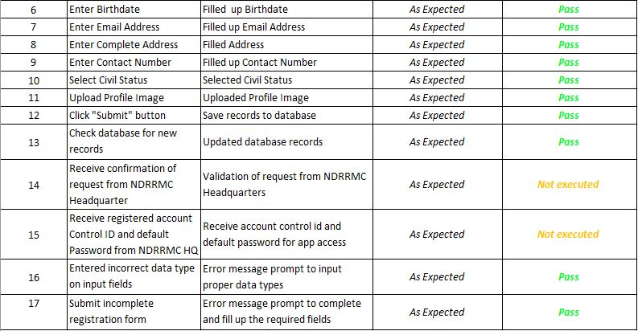

***Login as User (Mobile)***

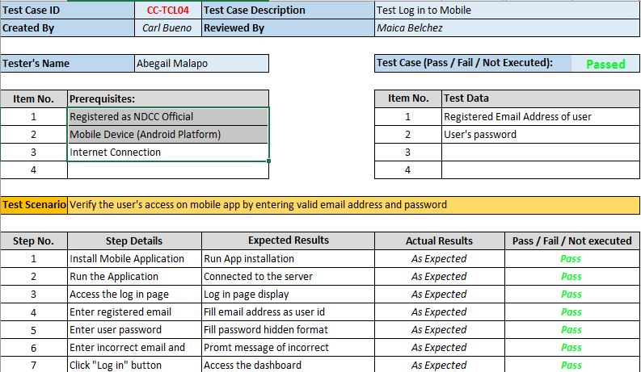

***Assessment on Mobile***

